

**Artificial Intelligence and Data Science Department.**

OS / Even Sem 2021-22 / Experiment 8.

**___________________________________________________**

YASH SARANG.

47 / D6AD.

EXPERIMENT - 8.

Basic commands of linux using kernel APIs.

**___________________________________________________**

**Aim:** Implement basic commands of linux like ls, cp, mv and others using kernel APIs.

**___________________________________________________**

**Output:**

First we create a new file named ‘hello.txt’ and writing sample text to file then using cat command to display the contents of file.

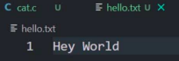

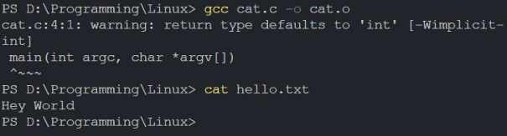

**__________________________________________________**

**Theory:**

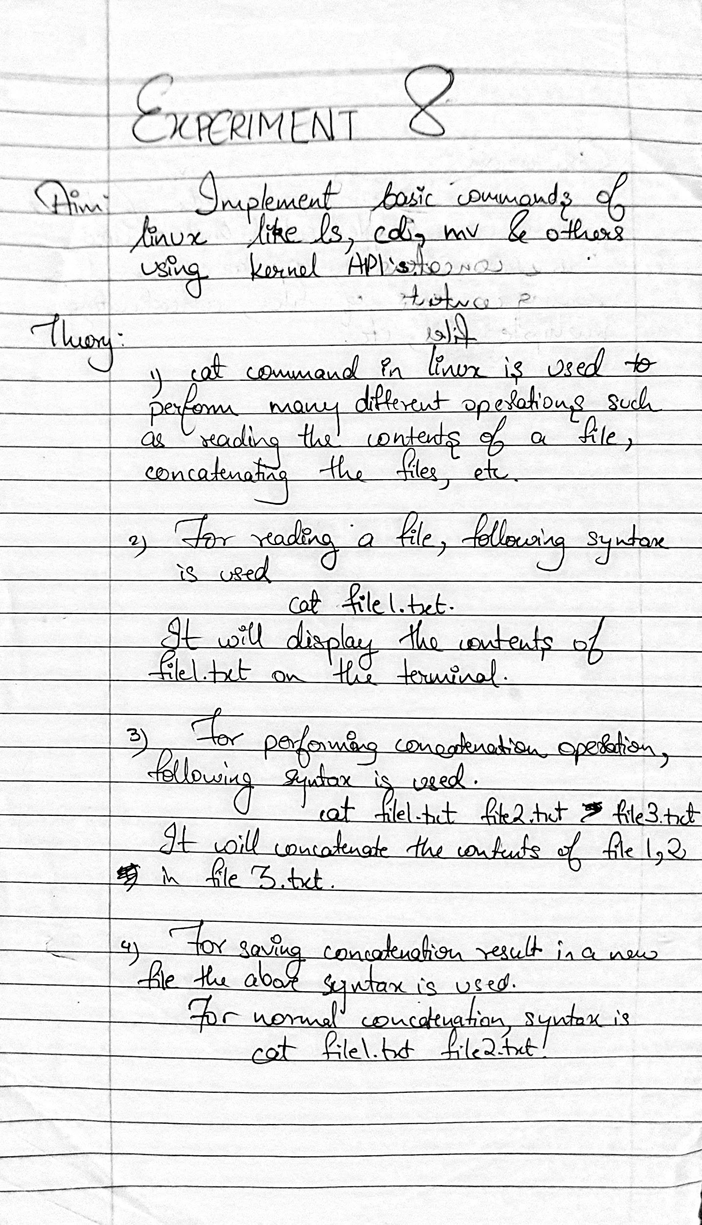

**___________________________________________________**

**Code:**

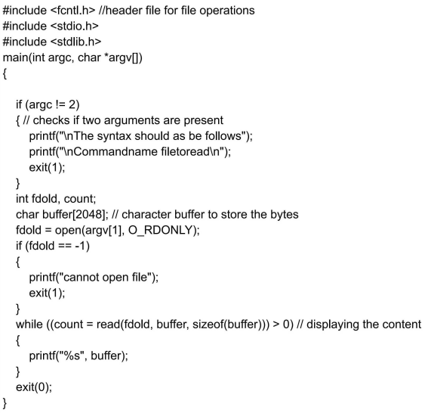

**___________________________________________________**

**Conclusion:-** 

